Day 23 – Forecasting Models

Baseline forecasting :

A baseline model is a simple model used to create a benchmark, or a point of reference, upon which you will be building your final, more complex machine learning model.

Naive forecast

The naive forecast is the simplest — it assumes that the next value will be the same as the previous value.

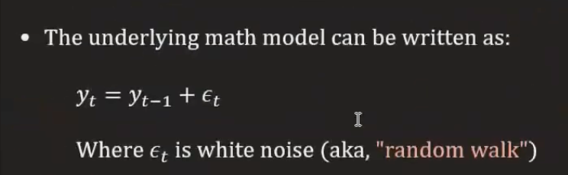
Tomorrow = Today
Whatever the last observed value is, use it as the next forecast.
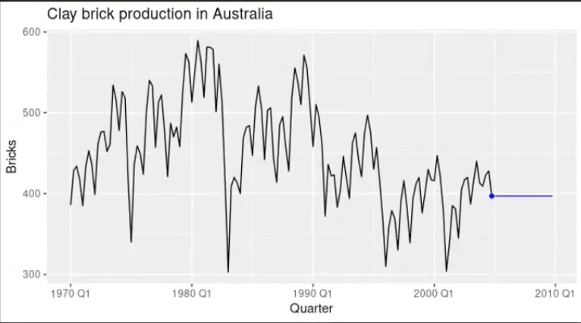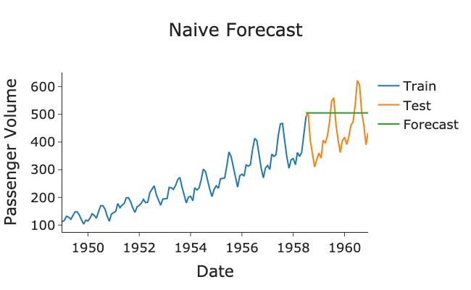

Moving average forecast

A moving average (MA) baseline model predicts that the next data point is the average of the last n data points.
Uses the average of the last k observations.
Instead of assuming tomorrow = today,
assume tomorrow = average of recent history.

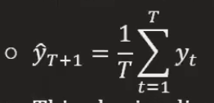
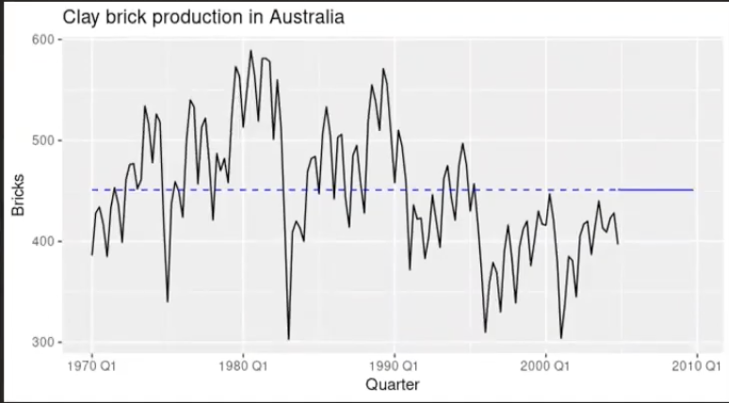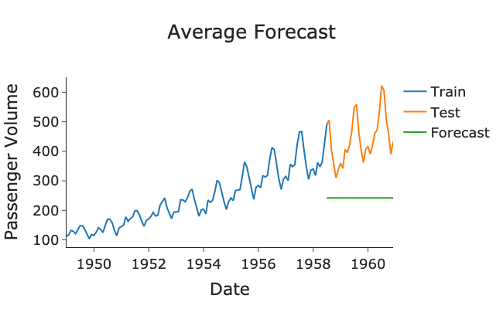

Drift Forecasting:
This is also an extension of the naive forecast where we let the prediction either linearly increase or decrease through time as a function of time step, h, scaled by the average historical trend:
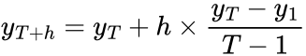
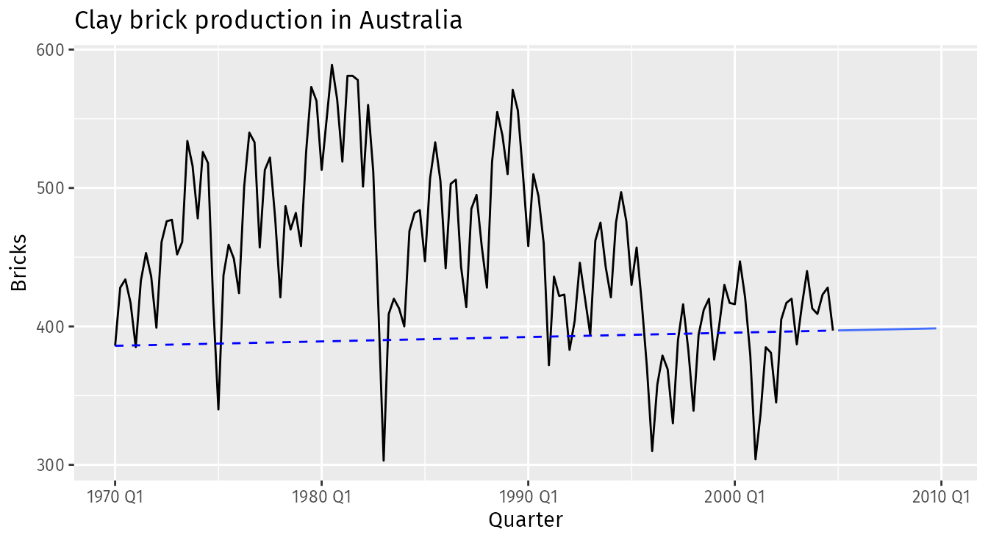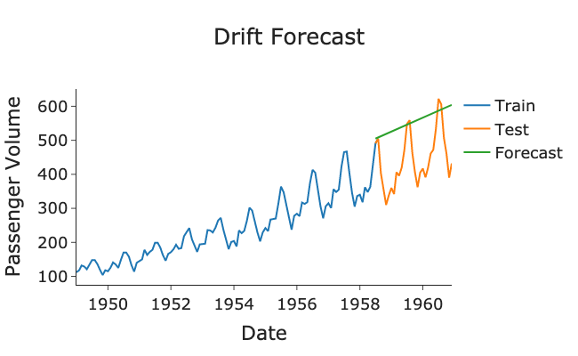

Seasonal Naive Forecasting:

This is an extension of the naive method, but this time the forecast is equal to the most recent observed value in the same season

Mathematically the model is written as:

Where m is the seasonality of the data. So, for monthly data with a yearly seasonality m=12, quarterly data would have m=4 and weekly data would have m=52.
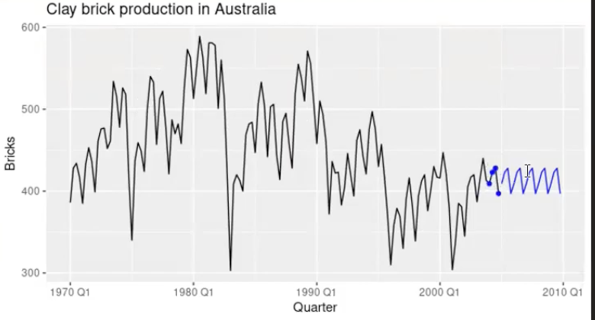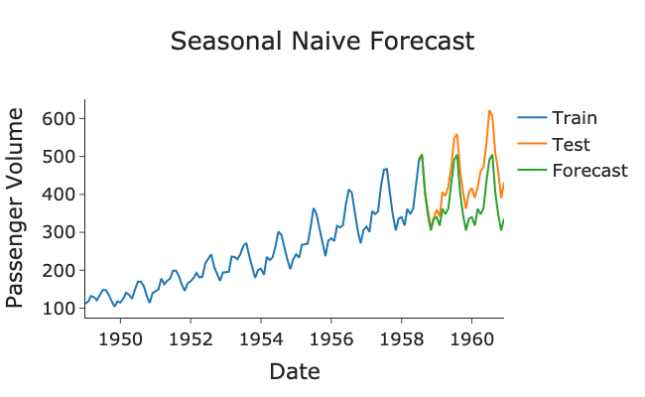

ARIMA:

AutoRegressive Integrated Moving Average

AutoRegressive - (P) Today value depends on previous day value.

If temperature for the last 3 days affects today:
yt=c+ϕ1yt−1+ϕ2yt−2+ϕ3yt−3+ϵtyt​=c+ϕ1​yt−1​+ϕ2​yt−2​+ϕ3​yt−3​+ϵt​
- Uses lagged values.
- p = number of past observations used.

Integrated - (d) Differencing step (It is done to bring stationarity)
It does this using differencing:
yt′=yt−yt−1yt′​=yt​−yt−1​
If trend still exists:
Second differencing:
yt′′=(yt−yt−1)−(yt−1−yt−2)yt′′​=(yt​−yt−1​)−(yt−1​−yt−2​)
- d = number of times differencing is applied.

Moving Average - (q) Past Error (Mistakes the model made during previous prediction)
yt​=c+ϵt​+θ1​ϵt−1​+θ2​ϵt−2​
- q = number of past errors used.

- For Auto Regressive we use PACF plot.
- For Integrated we use Dicki-Fuller test. If its less than 0.5(p<0.5) we can consider
- For Moving Average we use ACF plot

Intuition
Suppose we want to predict daily sales.
ARIMA thinks:
- What happened recently? (AR)
- Remove trend noise first (I)
- Correct mistakes from past errors (MA)
Then predict tomorrow.
Disadvantage:
It cannot handle seasonality.

SARIMA:
Seasonal AutoRegressive Integrated Moving Average
SARIMA(p,d,q)(P,D,Q,s)

Non-seasonal part
Same as ARIMA:
- p → regular autoregressive terms
- d → regular differencing
- q → regular moving average terms

Seasonal part
- P → seasonal autoregressive terms
- D → seasonal differencing
- Q → seasonal moving average terms
- s → seasonal period
Examples:
- Monthly data with yearly seasonality → s = 12
- Daily data with weekly pattern → s = 7
- Hourly data with daily cycle → s = 24

1. Seasonal AR (P)
Use values from previous seasons.
Example with monthly data:
This January may depend on last January.
yt=c+Φ1yt−12+ϵtyt​=c+Φ1​yt−12​+ϵt​
If P = 1, use one seasonal lag.

2. Seasonal Differencing (D)
Removes seasonal repetition.
Instead of:
Current month − previous month
Use:
Current month − same month last year
yt′=yt−yt−12yt′​=yt​−yt−12​
That removes yearly seasonality.

3. Seasonal MA (Q)
Uses seasonal forecast errors.
Maybe errors from last season help correct this season.
Conceptually:
yt=c+ϵt+Θ1ϵt−12yt​=c+ϵt​+Θ1​ϵt−12​

Intuition
Suppose monthly sales.
To forecast March 2026, SARIMA asks:
- What happened last month? (AR)
- What happened last March? (Seasonal AR)
- Remove trend? (d)
- Remove seasonality? (D)
- Correct past errors? (MA + Seasonal MA)
Then forecast.
That’s smarter than plain ARIMA.

Prophet
It was developed by Meta Platforms.
It was introduced by Facebook in the Data Science Team at the year of 2017.
Prophet = Trend + Seasonality + Holidays + Noise
- It works well without expert tuning(it can autotune by just initializing the model = prophet)
- It handles missing data.
- Handles holidays and special events.
- It is fast and scalable.

Trend (Growth over time.)
- Linear growth
- Logistic growth
Linear growth:
- Data grows at constant rate.
- Prophet specially has a changing point. It can automatically detect the changing point.
Logistic growth:
When data fluctuates and grows up and down.

Seasonality(Repeated patterns)
Examples:
- Higher ice cream sales every summer
- Weekend traffic spikes
- Monthly salary-day spending
Prophet automatically learns:
- Daily seasonality
- Weekly seasonality
- Yearly seasonality

Holidays / Events
Special events affect behavior.
Examples:
- Diwali sales spike
- Black Friday spike
- Festival travel demand
ARIMA struggles with these unless manually added.
Prophet handles them naturally.

Intuition
Suppose you forecast Uber demand.
Prophet thinks:
- Long-term growth trend exists
- Demand repeats every Friday night
- Holidays change behavior
- Combine all these to predict future.

